**2D Side Scrolling** – Infinite Endless Flappy Mobile TAP Game Documentation

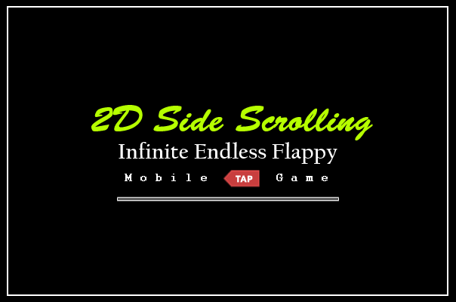

INTRODUCTION

**Thank you for buying this KIT, we really appreciate your support.**

**Welcome to 2D Side Scrolling - Infinite Endless Flappy Tap Mobile Game documentation. This will tell you everything you need to know about the KIT and how to start building your own game easy in 1-2-3.**

This is a kit which contains prefabs, models, scripts both in javascript and C# to create your own side scrolling tap game like other famous games where you have to tap to jump and evade the obstacles. This KIT provides you with scripts, models, animations, textures, sprites, prefabs and everything to start your own game, including an example projects along with a menu. You can drag and drop the prefabs to create your own game or just edit the example scene to your needs easy.

two mode spawners Features

This pack also have two type of modes for your game which is obstacle spawner advanced and obstacle spawner simple.

**Obstacle spawner** **simple** will only spawn a paired object (such as pipe etc.) within the spawn range time (so if you choose for 2 seconds, then it will spawn the paired object every 2 seconds) and the paired object will go up and down randomly so each time it will spawn it will be different.

**Obstacle spawner advanced** will allow you to choose up to 10 objects which you can spawn and by default there will be prefabs which will be spawned but they can be changed to your needs. Just like the obstacle spawner simple, you can also set the spawn range time however in the advanced one you can set the minimum and maximum time each object will be spawned so if for example you choose minimum of 2 and maximum of 5 then each object will spawn RANDOMLY between 2 to 5 seconds only.

tHIS PACK FEATURES

* Fully function and complete playable player with jump force, sounds, animations and more!
* Fully and ready to use game template for mobile, iOS and PC.
* 2 different modes.
* Advanced spawner which spawns up to 10 prefabs of your choice with given time.
* Simple spawner which spawns a pair of gameobject with given time.
* Finger touch controller for mobile.
* Mobile ready and mobile friendly.
* Endless infinite runner.
* Spawning object system feature.
* Beautiful and immersive art.
* Score feature and display score at game end.
* 2 features game modes.
* Full ready to use complete game with menu, game over screen, score system, movement and more!
* Over 25+ different obstacles ready to use in your game, just drag and drop.
* Create your own obstacles easy and set them up in-game.
* Over 10+ sounds, audio and music.
* Over 30+ prefabs and models.
* Obstacles generator feature which can be customizable.
* Fully function fadeout feature to start your game.
* Fully ready to use menu which can be customized.
* Customizable crosshair script.
* Fully function smooth game over feature with screen GUI.
* Customizable player speed.
* Fully function infinite runner game mode.
* Complete and different HUDs and GUIs.

What can I create with this?

This KIT is mostly used for creating a ‘tappy’ side scrolling game. This KIT includes the models and ready to use prefabs to just drag and drop so it is easy to create your own game. It also have features such as spawners, sound game end screen, score and more. You have playable player which you can start with including all features. You can create any type of tap platform game or such with any art style of your choice. This pack is also very easy to customize with your own sprites!

Create a new empty project

Create a new empty project, set defaults for 2D and Import this package into the NEW EMPTY PROJECT. **Please note:** Importing into an OLD Project may result in damaging your old project.

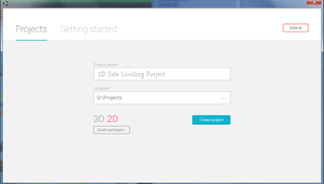

Import Package to unity

Import the package inside Unity using the import button, be sure that ALL are selected.

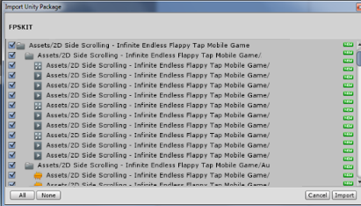

Explanation of files

**Animations folder**Animation folder contains all necessary animations. I advise not to touch these as they aren’t required unless you want to edit the animations.

**Audio folder**Audio folder contains all the KIT sounds and music including audio and sounds FX.

**Crosshair folder**A Folder which contains all your Crosshair GUIs which you can use.

**GUIs folder**Contains the GUIs prefabs to use in game such as the battery GUIs, HUDs, paper, notes and such.

**Materials folder**Materials folder are the simple materials for the models and prefabs.

**Obstacle Spawners Folder**This folder contains the prefabs which is used to generate and spawn the obstacles. You have a Obstacle Spawner Advanced and a Obstacle Spawner Simple. In the advanced folder you have 3 prefabs which you can use (top, bottom and middle) and you can also assign your own prefab which you want to spawn in these. In the simple folder you have 1 prefab which you just need to drop into the scene and assign your own prefab or a pair game object (such as pipe pair by default)

**Players folder**Contains the prefab of your player as a whole, ready to just drag and drop into your scene.

**Prefabs folder**Prefabs folder which contains all your general prefabs such as; Blockers to use so the player can’t get outside the main camera, the objects which you can spawn in the Obstacle Spawner Advanced, the paired objects which you can spawn in the Obstacle Spawner Simple, Scrolling prefabs for your background and ground and settings such as the Main Camera.

**Sprites folder**This folder contains all your sprites for the prefabs. Such as the house sprites, tree sprites, bird sprites and etc.

**Scenes folder**Folder that will contain the example scene and the main menu which you are free to modify.

**Scripts folder\***Important folder which contains IMPORTANT scripts for your game.

**Textures folder**Remaining textures used for your models, prefabs and such.

*Please note that the steps below will be based on ready to use prefabs from the KIT however you are free to create your own with your model and add the same scripts to your model instead, for the same results.*

Setting up YOUR GAME WITH **obstacle SPAWNER simple**

Now that you know what your folders are about, it’s time to start creating your own very first game!

Obstacle spawner simple will only spawn a paired object (such as pipe etc.) within the spawn range time (so if you choose for 2 seconds, then it will spawn the paired object every 2 seconds) and the paired object will go up and down randomly so each time it will spawn it will be different. It is very easy and will just spawn the prefabs in the middle camera. It’s similar mode to other popular tap games out there!

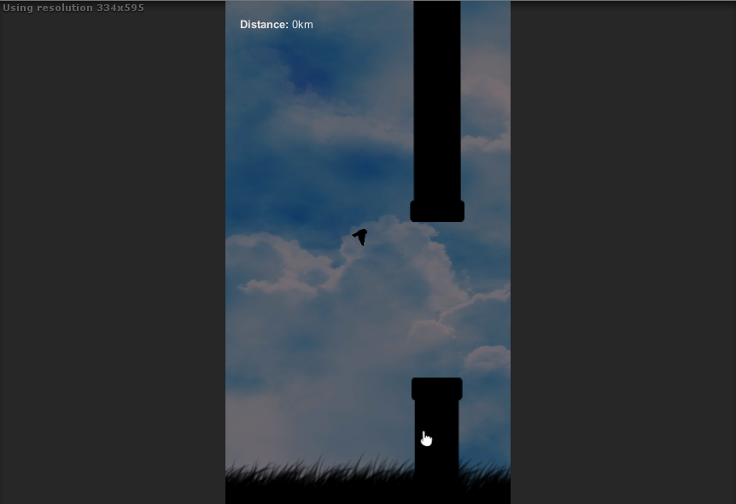

**Step 1**: Create a new scene, delete the Main Camera so your scene will be clean and new and in the folder, drag and drop the Main Camera into the scene. Also add a directional light in your game (this is not necessary, however some textures can appear dark and it is much better to create a directional light just in case mostly for the scrolling backgrounds)

**Step 2**: Go to the prefabs folder and navigate to the scrolling prefabs and in the backgrounds folder. Drag and drop a background of your choice in the scene, make sure it is in the middle where the camera is appearing and then go to the grounds folder and drag and drop a ground of your choice in the scene too. You can scale the ground for a better view in your camera. Go to the blockers folder and add the two blockers in the scene, make one on the top of the camera and one down. These are so the player can’t go outside the camera.

**Step 3:** Go to the player’s folder inside the prefabs and drag and drop a player of your choice into the scene. You can also customize the player speed, game end HUD and sound in the inspector.

**Step 4**: The scene is almost already done and if you play it you can see that the background moves and your player can jump. Go to the prefabs folder and in the Obstacle Spawner Simple folder drag and drop the prefab in the scene. Once that is done your game is ready and your spawner will spawn the pair (which is a pipe pair by default) and you need to avoid the pipes and if you hit the pipes, then the game will end and display the score.

If the Obstacle Spawner Simple is spawning too close to the player or it way to downwards then you need to put the Main Camera, Directional Light, Scrolling Background and Player a bit back or down from the spawner. You can also change the spawn range speed in the inspector of the Obstacle Spawner Simple. **See the F.A.Q page for more.**

EXPLAINGING the **obstacle SPAWNER simple**

The Obstacle spawner simple spawns a paired object ONLY in the scene. It mostly fits for pairs (such as pipes etc.) for the best results however you can use any gameobject you’ll like to spawn but would be best if you have a two gameobjects as a pair. (*For example*; one pipe down and one pipe up then add them as child to a pair gameobject and just put as a child in the whole pair which is the Obstacle Spawner Simple)

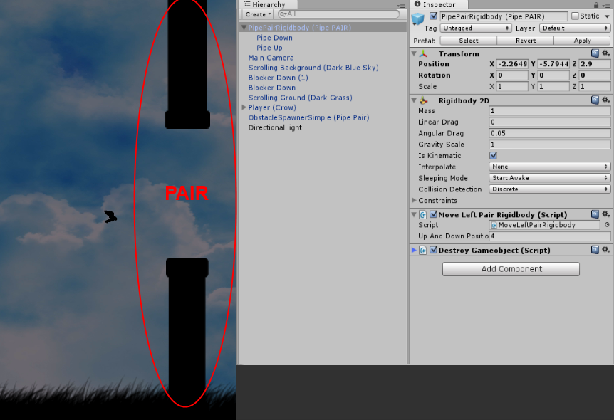

Just be sure that the objects are set as children of the pair just like in the screenshot.

You can also change the spawn range in the inspector. Also, the main pair ALWAYS needs to have a **2D rigidbody** in order to work.

If you also click on the main pair (that will be spawned) you will see a script called MoveLeftPairRigidbody which is the script which will be used to move the obstacles as pair to the left position and if you click on the children of the main pair you can see the pipes which will ALWAYS needs to have a 2D collider in order to work so when the player hits the collider then the game will end.

You can also see an ‘Up And Down Position’ on the main pair which is the position of the pair which will move a little bit up or down when it spawns so every spawn will be different and not always in the same position. If you increase the number for example then the pipe will go lower and if you decrease it then the pair will go more on top. This is by default at 4 and is recommended however it can be changed to your needs.

when **obstacle SPAWNER simple** spawns to close

Since the spawner is made to spawn with the camera points sometimes the obstacle spawner simple is too close to the player and keeps spawning there since it is staying with the camera’s perspective.

You need to move the whole scene except the spawner itself a little back when this occurs so you need to highlight every object in the scene except the ObstacleSpawnerSimple and move everything a little back or down (depending where it is spawning too close or to upwards)

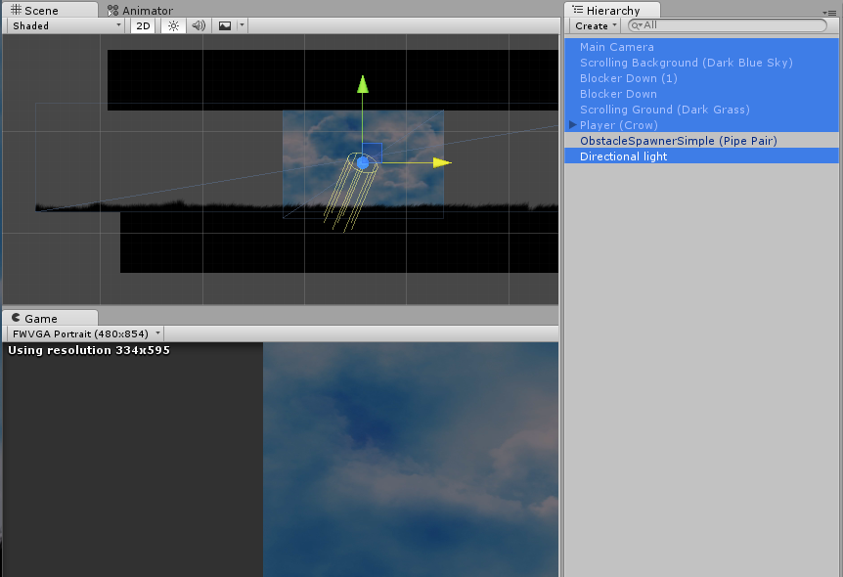

If you also click on the children of the Pair that is set to spawn on the ObstacleSpawnerSimple you can see the ‘Up And Down Position’ value. From here you can set when the pipes randomly spawn up and down so they will always be different. You can set any number you want and If you increase the number for example then the pipe will go lower and if you decrease it then the pair will go more on top. This is by default at 4 and is recommended however it can be changed to your needs.

**Once that is done and you got everything right the game is ready. You can click or tap and the player will jump depending on the jump force you set which can be set from the player inspector along with the game end GUIs and sounds. The score will display every distance you move and then display at the end of the game too to show you how much distance you traveled.**

Setting YOUR GAME WITH **obstacle SPAWNER ADVANCED**

Now that you created a game with the simple spawner it is time to make a game with the advanced spawner.

Obstacle spawner advancedwill allow you to choose up to 10 objects and do not need to be as pair because you can have as much obstacle spawner advanced as you like (unlike the other simple spawner which only allows 1 pair) and by default there will be prefabs which will be spawned but they can also be changed to your needs. Just like the obstacle spawner simple, you can also set the spawn range time however in the advanced one you can set the minimum and maximum time each object will be spawned so if for example you choose minimum of 2 and maximum of 5 then each object will spawn RANDOMLY between 2 to 5 seconds.

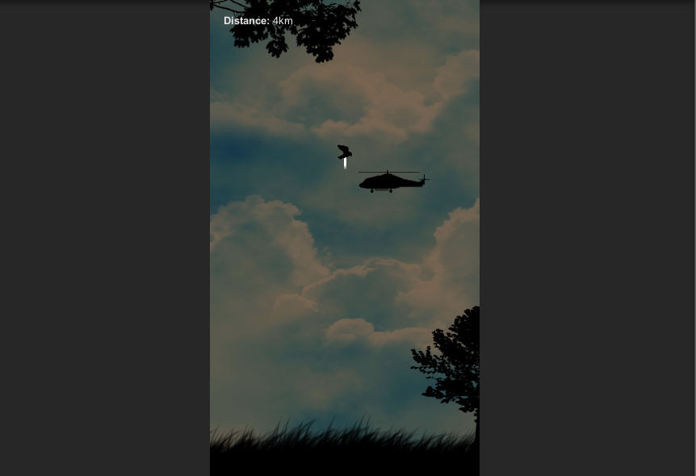

**Step 1**: Just like before you need to create a new scene, delete the Main Camera so your scene will be clean and new and in the folder, drag and drop the Main Camera into the scene. Add a directional light in your game and add a scrolling background and ground. Then in the blockers folder add two blockers in the scene just like before so the player can’t go outside the camera.

**Step 2:** Go to the player’s folder inside the prefabs and drag and drop a player of your choice into the scene. You can also customize the player speed, game end HUD and sound in the inspector.

**Step 3**: Go to the prefabs folder and in the Obstacle Spawner Advanced folder you can see 3 prefabs which are bottom, middle and upper. Since you can select up to 10 objects you can have as much spawners in the scene as you like, so you can have 1 for spawning ground objects (houses, etc.) 1 for spawning objects in the middle (such as helicopters etc.) and one for spawning upper objects (grass, clouds etc.) so go ahead and firstly drag and drop the Obstacle Spawner Advanced (Bottom) in the scene. Unlike the other spawner this doesn’t move with the camera’s perspective so you need to **make sure you set it in the bottom of the scene.**

If you play the scene you can see that the prefabs will now spawn in the ground.If they are offset or a little bit higher then you just need to grab the Obstacle Spawner Advanced in the scene and move it more down near the ground grass. Now go ahead and add the other spawners in the upper and middle of the scene. Make sure you set them as they are so if it is the Obstacle Spawner Advanced (Middle) then it is set in the middle. You can also set the minimum and maximum spawn range for each object from the spawner’s inspector.

EXPLAINGING the **obstacle SPAWNER ADVANCED**

The Obstacle spawner advanced spawns up to 10 objects in the scene unlike 1 as a pair. You can also have as many Obstacle Spawner Advanced in the scene as you like because they spawn as a single object so having up to 3 is ideal for spawning 1 in the bottom, 1 in the middle and 1 for the top. You can also set the minimum and maximum spawn range of each object.

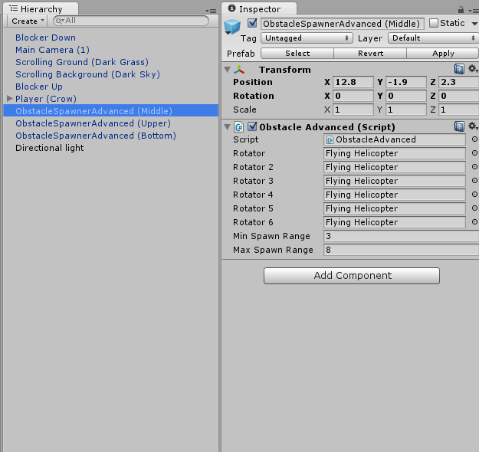

For example is the spawn range is 3 to 8, then each objects will spawn from 3 to 8 seconds randomly.

You can set any object to spawn of your choice in the Obstacle Spawner Advanced just be sure that the objects that you are spawning have a collider so when the player hits it then the game will end. Also, each object that will be spawned will need to have a collider and the MoveLeft.cs script which will make the object move left, otherwise it will spawn and stay on screen. Also you can change the speed of each object in the scene that will be spawned, so for example you can set the speed of the helicopter to something greater then spawning a tree.

Changing the **SCROLLING** **backgound and ground**

Normal sprites uses the MoveLeft.cs script which makes the sprite move, however grounds and background will stay on place so they won’t be set as sprites but texture instead so they can scroll the texture using the Scroll.cs script.

First thing, be sure that the image you have is selected as a Texture and not as a Sprite 2D and UI and also change the wrap mode to repeat and click apply. This is an important step otherwise it will not work.

This now means we need to create a ‘3D’ object in order to use the texture since the script is scrolling the texture and not the sprite as a whole so go ahead and create a 3D cube and delete the collider and assign the texture that you want in the cube. Position the object correctly as it may be in a weird position. Then add the script Scroll.cs and set a speed of the scroll that you want.

For the scrolling ground, it is the same thing and If you have a ground which is transparent then you need to change the shader to Unlit > Transparent. Otherwise, you’re good to go!

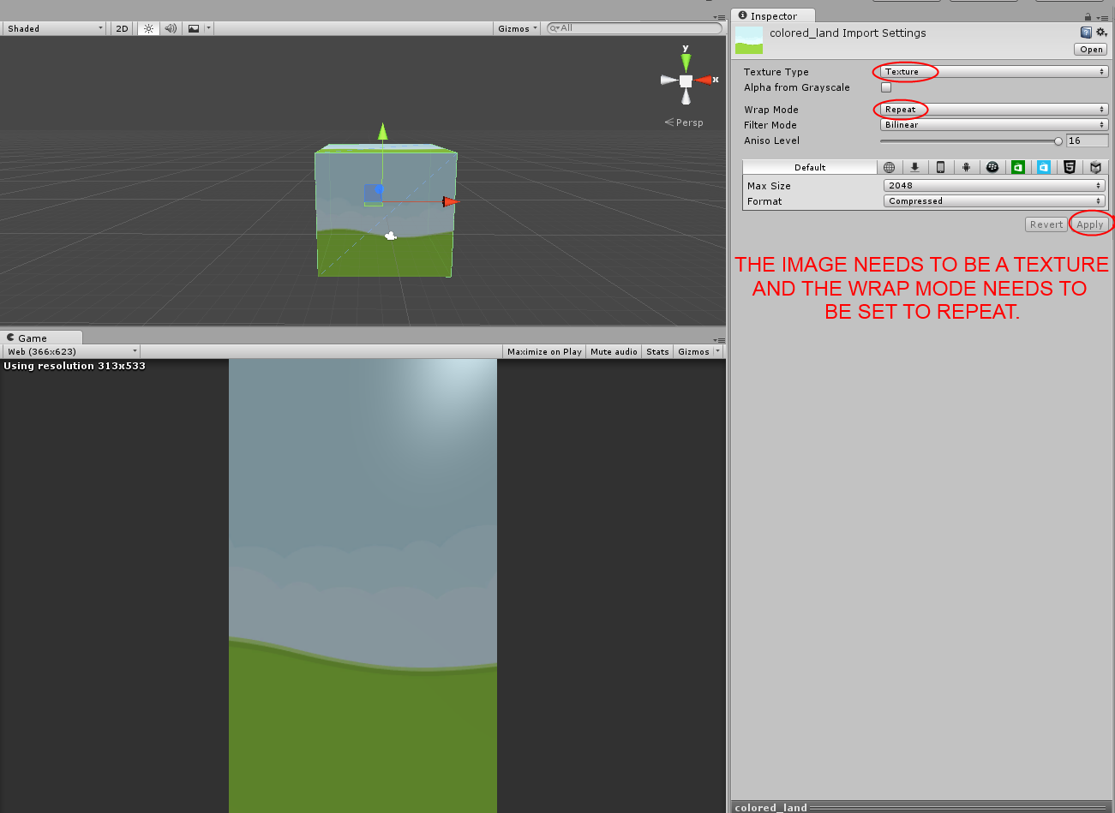

It is very important that you set the image as a texture and wrap mode to repeat otherwise it will not scroll correctly. You need to position the cube in the correct position too for your scene. If you are doing a ground instead, it is the same procedure just apply the ground texture and you are good to go.

If you are in doubt you can always use the prefab which is used as the scrolling background in the Scrolling Background folder. Drag and drop the prefab in the scene and just change the texture (albedo) from the inspector.

Changing the **WHOLE SCENE (RESKIN and adding yours)**

The game is very easy to just set it up with your own sprites and reskin it.

**Player:** To add a player of your own (we assume that you already have the sprite of the player such as an alien character for example like below) all you have to do is drag and drop the sprite and add a **rigidbody 2d**, an **audio source** and a **collider 2D** to the sprite. Assign the Player.cs script and edit the end game background, foreground, score GUIs and game end sound.

**Background:** Just like on page 10, all you have to do is get a sprite or a texture and make it as a texture and put the wrap mode as repeat and add the script. Then drag and drop it into the scene or just change the Scrolling Background prefab’s texture to your needs. **See question 20 on F.A.Q for more.**

**Objects:** if you need to add your own objects for the Obstacle spawner advance then just add the sprite into the scene and add a collider 2D to the sprite. Assign the MoveLeft.cs and the DestroyGameobject.cs on the sprite and just set it as a prefab by dragging it in the projects and you can use it for the obstacle spawner advance. Otherwise for the obstacle spawner simple then find the PipePairRigidbody (Pipe Pair) and change the sprites to your needs and change the colliders since every sprite will be different and vary. **See question 11/15 on F.A.Q for more.**

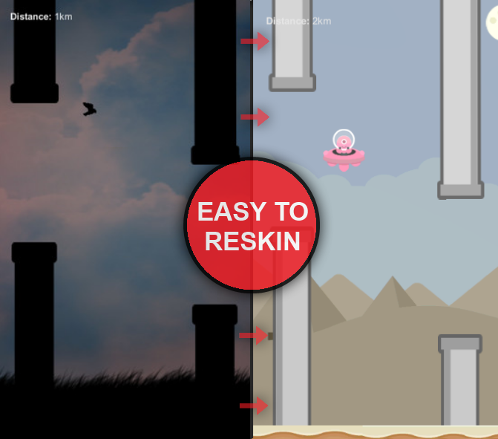

Finishing your game and f.a.q

If you finished all the steps then you may have a basic idea of all the features in the KIT. Please note that you can use your own objects and sprites instead. Below we will do the F.A.Q and hopefully answer any questions you may have regards the KIT. If you are in doubt or stuck, be sure to check out the F.A.Q below and be free to use the example scenes provided to learn from them. The example scenes and prefabs are a great way to learn more. Enjoy your game making journey!

**1. Who is this KIT made for?**

This KIT is made for anyone who would like to experiment, learn and create a similar or any other game. This KIT will provide you the scripts you need to create it for both new users and who are willing to learn more.

**2. What is this KIT focused on?**

The main reason this KIT was release was for creating any type of platform tap mobile game.

**3. Can I add my own sprites instead of the KIT’s?**

You can add as many sprites and edit as your own objects as you want.

**4. How do I change the background music?**

The background music is just an audio in the player which can be changed in its inspector.

**5. How do I change the player’s jump force?**

Go to your player in your scene and in the inspector you should the player script. There is a Jump Force and you can set the X and Y for it.

**6. How do I change the game end GUIs and HUDs?**

Go to your player in your scene and in the inspector you should see the player script. There is the end game hud background and foreground and the sound that will play when the game ends.

**7. The game is in a dark style, can I make it brighter?**

It’s the art style of the KIT so some sprites are dark for its purpose. However, the player is just a filled with black color so you can change the color from the inspector of the player and set it to white. Now you have a bird instead of a crow ☺

**8. When the game starts, it plays that annoying crow sound in the begging. How do I change this?**

You can change that ‘annoying crow sound’ from the Main Camera in your scene and in the Start Sound, choose a sound of your choice that you wish to play when the game start.

**9. How do I change the crosshair?**

You can change the crosshair from the Main Camera in the crosshair script and choose one of your choice from there.

**10. How can I change the speed of each object of the Obstacle Spawner Advanced?**

You can set each speed of each object that will be spawned. First you need to locate the objects that are spawned in the scene which are in the prefabs folder and there is the bottom objects, middle objects and upper objects. Click on the object of your choice and in the inspector you can see a Speed in the MoveLeft script. You can change this for each object to your choice.

**11. How do I create my own objects that will be spawned for the Obstacle Spawner Advanced?**

You can create your own very easily. Let’s say you have a house sprite you want to add to spawn in the obstacle advanced spawner, all you have to do is put the house sprite into the scene and add a collider to the sprite. Go to the scripts folder and add a MoveLeft.cs and a DestoryGameObject.cs script to the sprite. Then add it as a prefab in Objects You Created or any other folder and assign the prefab you just created into the Obstacle Spawner Advanced.

**12. How do I change the scroll speed for the scrolling backgrounds?**

Go to the prefab folder and in the scrolling prefabs and find the prefab you want to change. Click on it and in the inspector you can see a Speed and just change it to your needs.

**13. How do I change the minimum and maximum spawn rage of the Obstacle Spawner Advanced?**

All you have to do is go to the Obstacle Spawner Advanced inspector and in the Min Spawn Range and Max Spawn Range change it to your own choice.

**14. How do I change the speed of the Obstacle Spawner Simple?**

All you have to do is go to the Obstacle Spawner Simple inspector and in the Spawn Range change it to your own choice.

**15. How do I create my own pair object that will be spawned for the Obstacle Spawner Simple?**

Firstly you need to be sure you have a gameobject as a pair so for example, you have one pipe for the upper area and one pipe for the bottom area. Add the pipe into the scene and add a 2D collider. Duplicate the pipe and add one for the upper area too with the same settings applied. Then create an empty gameobject and add a 2D rigibody to the empty gameobjects and set Is kinematic to true and add the pipes as a children of the empty gameobject and in the scripts folder find and add the MoveLeftPairRigidbody.cs script to the empty gameobject. Make the gameobject as a prefab and put it in the folder, then just assign it as a prefab into the Obstacle Spawner Simple and it should spawn with your sprite that you done. **See the screenshot below for more.**

**16. I don’t feel like doing anything because I feel lazy. Is there anything to more ease?**

We created a whole scene as prefab ready to drag and drop into your game scene. All you need to do is drop the player and you are good to go. Also the example scenes are provided if you wish to edit them ☺

**17. Can I use my own sprites with these instead the ones in stock with the KIT?**

Yes! The main reason we done this pack is to make it easier for people who want to create a tap game with their own sprites and as a bonus we added our own ones. You can change anything to your own sprites.

**18. When I lose and the game ends, it displays the error ‘Level Menu (1) couldn’t be loaded etc.”?**

You need to assign the menu to the build. Go to the build settings and add the Menu, DemoSimple and DemoAdvance and then try again. Whenever the game ends it will take you back to the menu screen.

**19. When the objects of the Obstacle Spawner Advanced spawn they disappear quickly.**

This could be the reason that the spawner is far away from the player, so when it spawns it get destroyed before it reaches the end of the other screen. You can move it more close to the player or change the speed of the object when it destroys as it spawns from the DestoryGameobject.cs script.

**20. How do I add my own scrolling background or scrolling ground that I wish to use?**

Unlike the normal sprites, for the scrolling background and scrolling ground we need to use a texture instead of a sprite. First thing, be sure that the image you have is selected as a Texture and not as a Sprite 2D and UI and also change the wrap mode to repeat and click apply. This now means we need to create a ‘3D’ object in order to use the texture since the script is scrolling the texture and not the sprite as a whole so go ahead and create a 3D cube and delete the collider and assign the texture that you want in the cube. Then add the script Scroll.cs and set a speed of the scroll and you’re done. For the scrolling ground, it is the same thing. If you have a ground which is transparent then you need to change the shader to Unlit > Transparent. Otherwise, you’re good to go!

You should test it out and now you have a scrolling background or scrolling ground with a texture!



If you have any difficulties, just use the other Scrolling Background prefab and change the texture from there.

**(Question 11) The pair gameobject always needs a Rigidbody 2D and the Move Left Pair Rigidbody script. Also you need a sprite (pipe in this case) both for the top and bottom with a collider.**

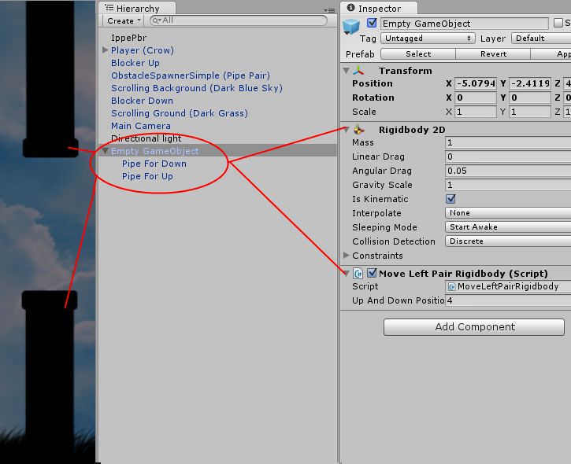

Remember thatyou can always edit the example project to your needs and learn from it. If you have any questions regards the pack, please do not hesitate to contact us and we will help you as we can.

CREDITS and special thanks

Special thanks to however contribute to this pack and especially, **to you**. Thank you for your purchase and for your support!

**Will this pack be updated and do you have any more planned features?**

This KIT is still young and new and needs to grow and we plan on updating this package. We are working on improving this KIT and if any of you have any suggestions or feedback please don’t hesitate to let me know. We will do our best to update the KIT frequently and even plan on adding more artwork and sprites too apart from the ones that are already in.

**Credits and special thanks:**

MoikMellah for the animated bird sprites. (CC0 License Public Domain)

Cptx032 for the art and animated demon hand. (CC0 License Public Domain)

Anyone that helped out with the project

If anyone have any inquires, if someone is missing or you have any questions or feedbacks please don’t hesitate to contact us on our official website.

**Thank for your purchase and enjoy. Happy game making journey!**